**18ECE206J ADVANCED DIGITAL SYSTEMS DESIGN**

**Fourth Semester, 2021-22 (Even semester)**

SRM Institute of Science and Technology College of Engineering and Technology

Department of Electronics and Communication Engineering

#### Name :

**Register No. :**

**Day/ Session :**

**Venue :**

**Title of Experiment :**

**Date of Conduction :**

**Date of Submission :**

|  |  |  |
| --- | --- | --- |
| **Particulars** | **Max. Marks** | **Marks**  **Obtained** |
| Pre lab and Post lab | 10 |  |
| Lab Performance | 20 |  |
| Simulation and results | 10 |  |
| Total | 40 |  |

**REPORT VERIFICATION**

**Staff Name : Signature :**

# 4. Implementation of Hazard Free circuit

### Aim: To design and implement a hazard free circuit Software requirements: Logisim

Theory:

If the input of a combinational circuit changes, unwanted switching variations may appear in the output. These variations occur when different paths from the input to output have different delays. If, from response to a single input change and for some combination of propagation delay, an output momentarily goes to 0 when it should remain a constant value of 1, the circuit is said to have a static 1-hazard. Likewise, if the output momentarily goes to 1 when it should remain at a constant value of 0, the circuit is said to have a 0-hazard.

When an output is supposed to change values from 0 to 1, or 1 to 0, this output may change three or more times; if this situation were to occur, the circuit is said to have a dynamic hazard. Figure 1.1 shows the different outputs from a circuit with hazards. In each of the three cases, the steady-state output of the circuit is correct, however, a switching variation appears at the circuit output when the input is changed.

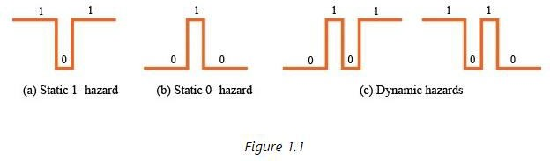

Problem Statement: Design a circuit with the following expression F=AB’+BC. Suggest whether the

given circuit is hazard free. If not design a hazard free circuit for the same.

K-Map for the given

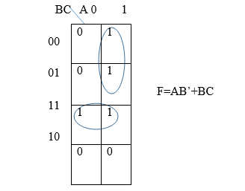

K-Map for Hazard free circuit

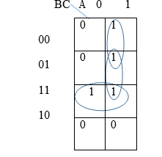

F=AB’+BC+AC

Pre-lab questions:

1. Write down the causes of hazard in Digital Circuits
2. Define Race around condition in a digital circuit.
3. How to remove hazard from Digital Circuits?

Post-lab questions:

1. Design a static-1 hazard free circuit F=∑m(1,4,5,10)
2. How does Hazards affect a sequential circuit?
3. Eliminate the 0-hazards in the given Boolean expression Z =∑(0,1,4,5,6,7,14,15)

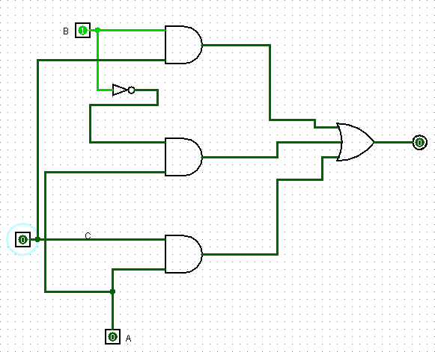

Result: